# 1St floor

# Entry：

## A:

Abacus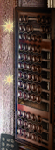

African mask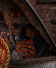

## B:

bagles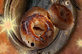

bamboo steamer 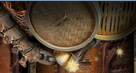

Birdhouse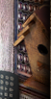

Black cat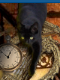

bugle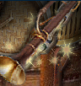

bug 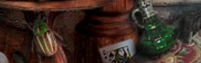

banana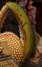

bagofnuts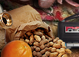

ballet slippers 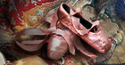

bamboosteamer蒸笼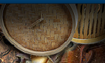

## C:

Coconut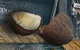

Castle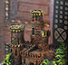

Cupcake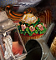

clothespin 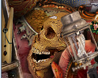

Cooking pots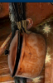

cassette recorder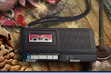

## D:

dollar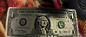

## E:

## F:

Firewood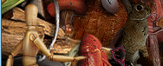

fan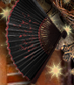

fish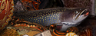

falcon 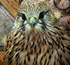

flask 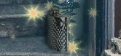

## g:

Gas lamp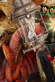

Garlic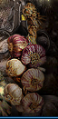

## h:

headphones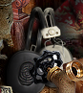

harp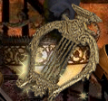

helmet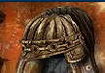

## L

Lobster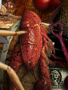

## m:

Mousetrp 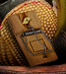

Moth 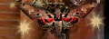

maracas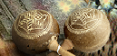

mushroom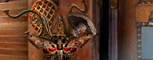

mandolin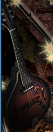

Nest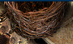

## O:

orange

Onion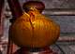

oil can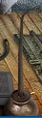

## P

Playing card 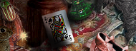

Pintbrush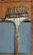

pizza slicer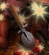

potion bottle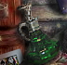

## R:

Rifle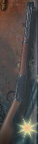

Remote control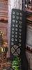

rabbit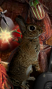

rope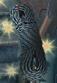

## s:

Stek 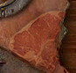

stopwtch 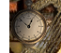

Shears大剪刀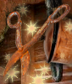

Sombrero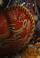

shovel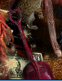

spine脊椎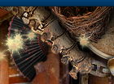

sunglasses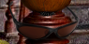

spoon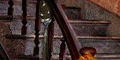

sledge hammer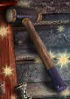

shoe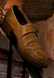

surgical clamps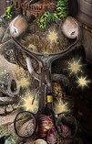

snake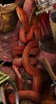

## T:

Two shells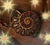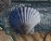

tomatoes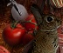

## v:

valve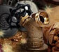

## w:

Wooden figure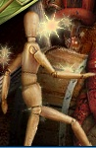

wig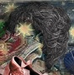

waffle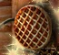

wrench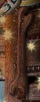

watering can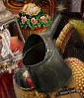

whisk 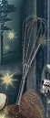

x:

y:

z:

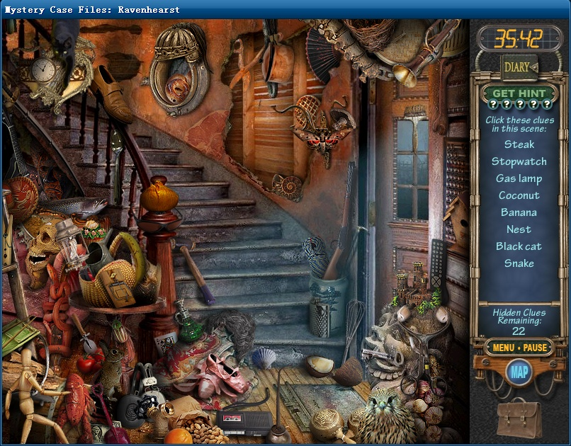

# front porch:前门廊

## a:

alarm 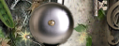

artichoke 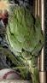

acorn 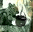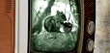

## b:

baseball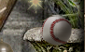

bunny 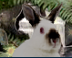

beer can 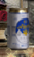

broccolli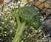

beetle 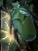

## c:

caterpillar 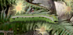

cactus 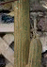

circuit board 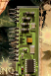

clarinet 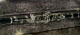

cupie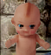

comb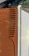

cow skull 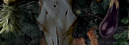

cuffs 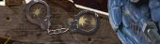

crutch 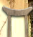

clef

## d:

## e:

elephant 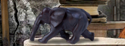

eggplant 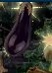

## f:

fish

## g:

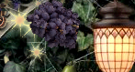

## h:

hat 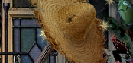

handDrill 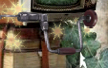

honeydipper 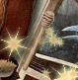

hourglass 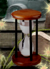

helmet

## i:

ice cream 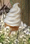

## j:

## k:

## l:

level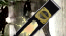

lgloo 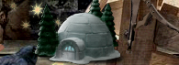

lime 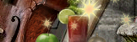

lgloo圆顶屋

## m:

Melon 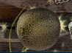

moth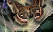

mr.frog 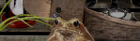

## n:

nut and bolt 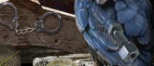

## o:

## p:

peas 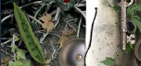

pear 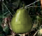

pepper 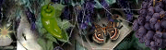

pineapple 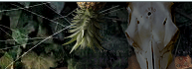

phone 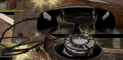

potion bottle

pretzel 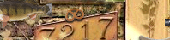

## q:

## r:

rake 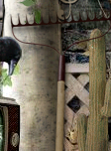

record 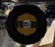

## s:

safetypin 

saw 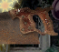

spigot龙头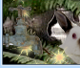

service bell 

shuttleecock羽毛球 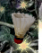

shaker 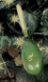

shell 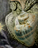

steak 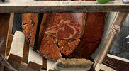

spear矛 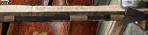

spider 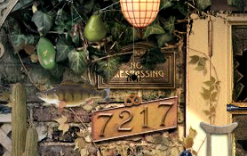

squash 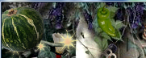

## t:

tape 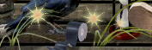

texas 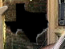

teeth 

tire iron 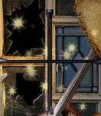

two lizards 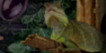 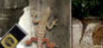

two brushes 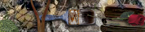 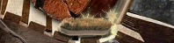

## u:

## v:

vise grips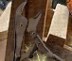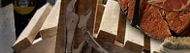

## w:

## x:

## y:

## z:

# parlor

## a:

angel 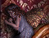

arrowhead 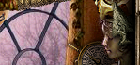

## b:

basket 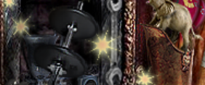

beetle 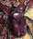

bullfrog

briefcase 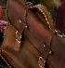

baguette

barbell

bone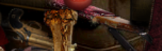

bottle 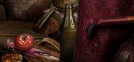

butterfly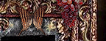

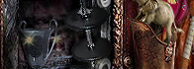

## c:

calculator 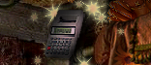

camera 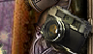

crown 

coin rolls 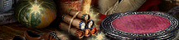

corkscrew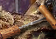

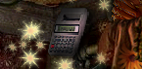

Chcolate cake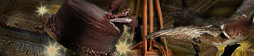

## d:

dentures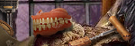

dial

dragon 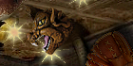

duck 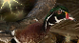

dominoes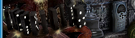

## e:

eggbeater 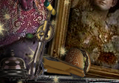

elephant 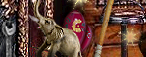

## f:

fan 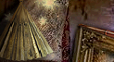

frying pan 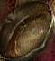

flat drum 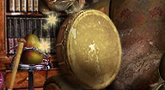

## g:

grapes 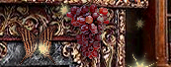

guitar吉他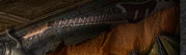

## h:

hamburger 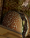

hammer 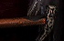

handbag 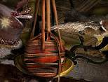

## i:

iron 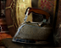

## j:

## k:

## l:

lantern 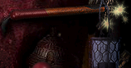

life vest 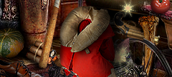

## m:

maracas

mitt 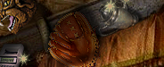

mro 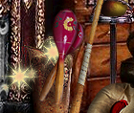

microphone 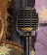

mocroscope

## n:

## o:

## p:

pear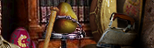

pinecones 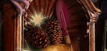

pen 

pipe 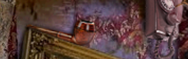

party hat 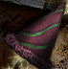

pocket knife 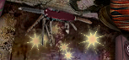

## q:

## r:

## s:

seashell 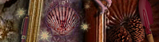

service bell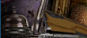

shovel

slingshot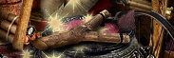

siren

shoes 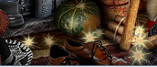

sombrero 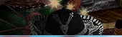

squash 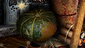

## t:

tamborine

telephone 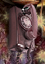

teapot 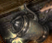

teacup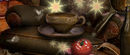

trophy 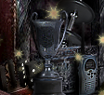

trukey baster 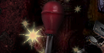

## u:

## v:

## w:

walkie talkie

wrench

water valve 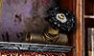

## x:

## y:

## z:

# dining room 餐厅

## a:

arrowhead 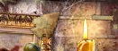

## b:

box vutter

bananas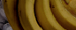

bike pump自行车打气筒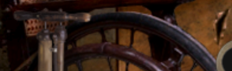

brain

## c:

cactus 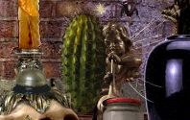

calipers 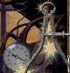

cupid 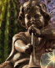

cherry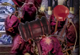

chocolate cone 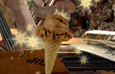

clothespin

corkscrew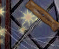

cigar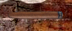

## d:

dice 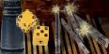

dog bone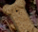

drum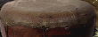

## e:

Eiffel tower 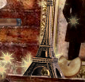

## f:

faucet 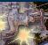

file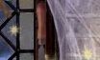

football 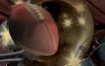

fortune cookie 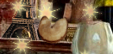

fountain pen

frog 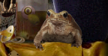

## g:

gavel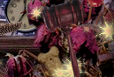

gargoyle石像鬼

golf clubs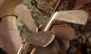

glasses 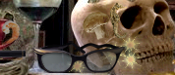

## h:

horseshoe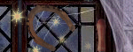

## i:

ice cream bar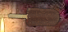

## j:

jack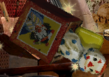

## k:

## l:

leg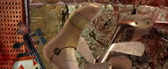

lure 

light bulb 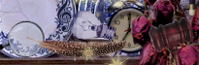

## m:

muffin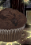 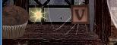

mushroom 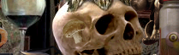

moth 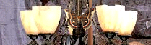

maple leaf 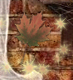

machine gun 机枪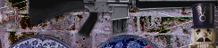

## n:

nest

## o:

orange slice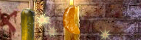

## p:

pacifier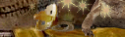

paintbrush 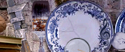

pen 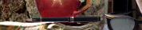

pepper grinder 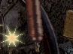

plunger 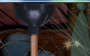

pretzel

pickle 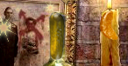

PINEAPPLE 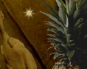

## q:

## r:

rubber chicken 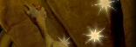

## s:

safety pin

saw

solier 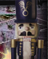

seahorse 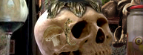

scissors 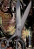

seven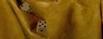

shovel 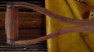

shrimp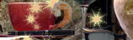

## t:

top

three after s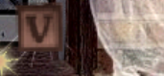

two bells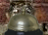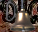 

two beetles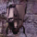

## u:

## v:

violin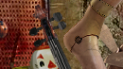

## w:

wrench

## x:

## y:

## z:

# servant’s quarters

## a:

anarchy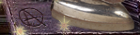

auger 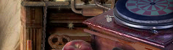

axe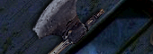

## b:

ball of string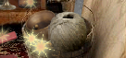

baseball bat 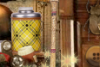

bell 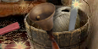

bottle opener 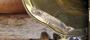

brown bottle 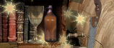

brown envelope 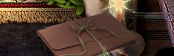

bread loaf 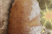

bike tire

billiard ball 

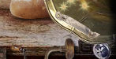

## c:

caterpillar 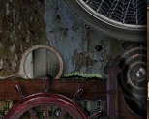

## d:

dollar bill 

duct tape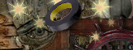

## e:

eye 

## f:

film reel 

## g:

goblet

green beans

## h:

hand drill 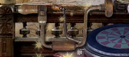

hand print 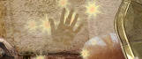

hand saw 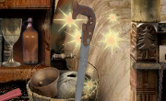

honey dripper 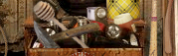

horn 

horseshoe 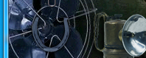

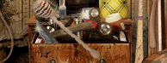

## i:

iron 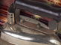

## j:

## k:

## l:

lantern 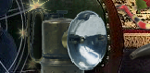

lipstick口红 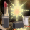 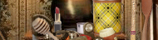

## m:

metronome 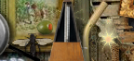

moth 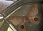 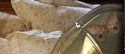

mushroom 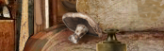

mirror 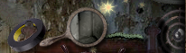

## n:

noose 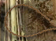

## o:

olive 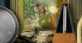

## p:

pretzel 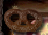

paperclip  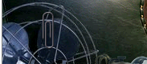

pick hammer

pine tree 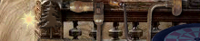

pistol 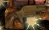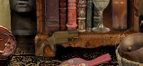

## q:

## r:

## s:

seashell 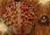 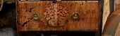

sawblade 

skillet

shears 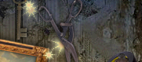

snake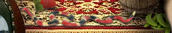

strawberry草莓

sewing button 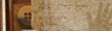

soup bowl 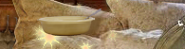

stovetop 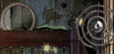

## t:

thermos 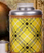

telescope 

teapot

two beetles

## u:

## v:

## w:

wasp 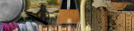

wooden fork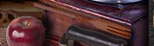

wooden spoon 

watermelon 

## x:

## y:

## z:

# kitchen

## a:

## b:

badminton racket 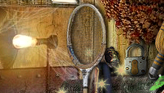

bbq wing 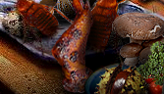

bellows

bonsai tree 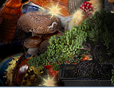

broom head 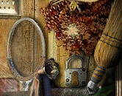

Buddha

## c:

cat 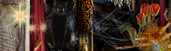

cocktail 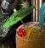

camera 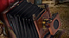

cheese grater 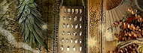

chestnut

conch shell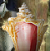

clamp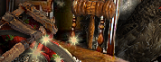

copper piping 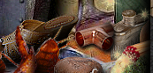

## d:

doorbell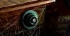

door knocker 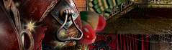

## e:

elephant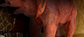

## f:

feather 

fortune cookie flask

fan 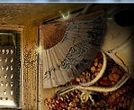

## g:

gas mask 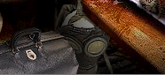

gavel

glove 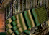

## h:

horn 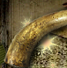

hamburger 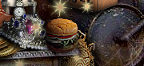

## i:

Indian corn 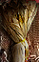

## j:

## k:

## l:

lady statue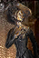

lion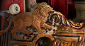

## m:

matches

masquerade mask 

maracas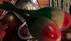

meat cleaver

mushrooms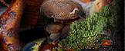

## n:

## o:

old letter 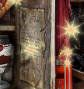

## p:

padlock 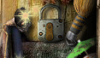

paintbrush 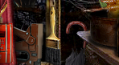

pineapple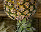

pinecone

pizza 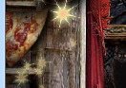

pouch 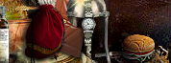

## q:

## r:

radio 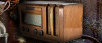

rooster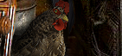

## s:

sundae 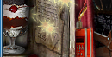

saxophone 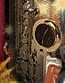

spade 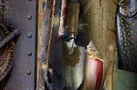

spider 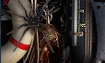

straw hat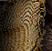

string ball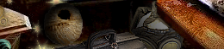

## t:

telescope 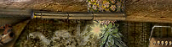

the jack 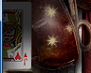

thermometer 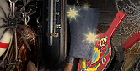

tiara 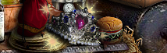

tulips 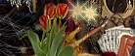

trout 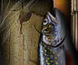

u:  
umbrella 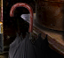

## v:

## w:

wallet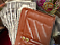

watering can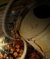

woman’s sandal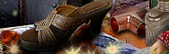

wristwatch

## x:

## y:

## z:

# garden

## a:

anchor

avocados 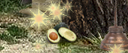

## b:

book stack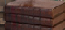

brass bell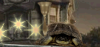

boccoli 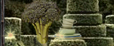

c:

cone 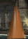 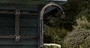

canoe

carrot

chair 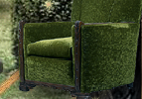

chopsticks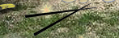

cinder block 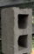

clippers

coat tree

cowboy hat 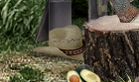

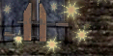

## d:

deer hear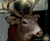

dishes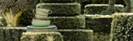

duck 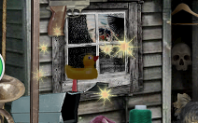

dinosaur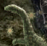

dinnerfork

## e:

## f:

fan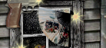

flag 

flask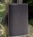

flying saucer

faucet

file

## g:

gramophone 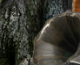

gray lizard 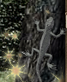

grapes

green lantern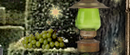

green lettuce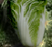

## h:

half moon 

hanger

heart 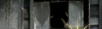

## i:

## j:

## k:

## l:

ladder 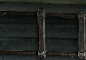

leather belt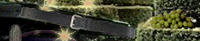

lips 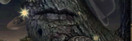

## m:

mailbox 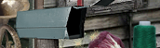

mushrooms 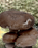

## n:

nautilus贝壳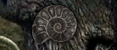

## o:

oil can

## p:

pheasant 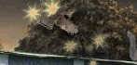

pitcher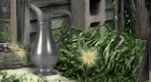

pineapple 

pistol 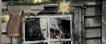

## q:

## r:

rake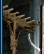

red cabbage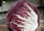

## s:

scrolls 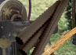

skull 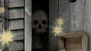

spade 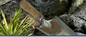

spoon

stamp 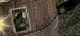

stapler

squirrel 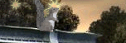

## t:

turtle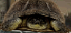

two bowlers 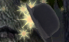 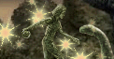

two gangers 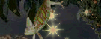 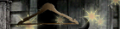

two horns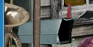 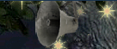

two masks

tribal mask 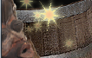

## u:

## v:

vise grips

vent

## w:

washboard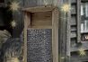

wood clamp 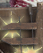

wreath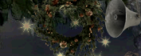

## x:

## y:

yarn 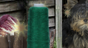

## z:

# garage：

## a:

## b:

bicycle 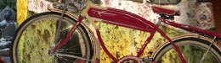 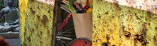

boxing glove 

brussel sprout 

## c:

canoe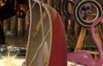

cinder block

## d:

dinosaur

## e:

## f:

face 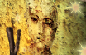

false teeth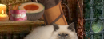

fan 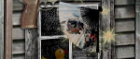

funny glasses 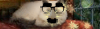

## g:

grapes 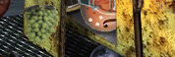

groceries 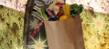

## h:

hand 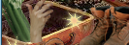

hand grenade

headphones 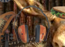

## i:

## j:

## k:

## l:

leather belt 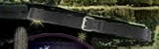

lightning bolt 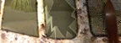

## m:

## n:

## o:

oil can 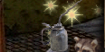

## p:

party hat 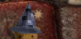

peanut 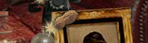

phone 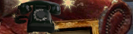

pocket knife 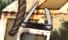

## q:

## r:

radio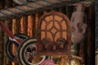

rake 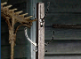

red telescope 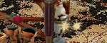

rose 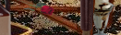

## s:

shades 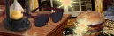

soldier 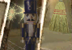

statue 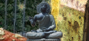

steamboat 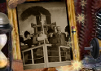

## t:

telescope 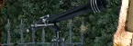

turkey sandwich 

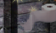

toilet paper

two airplanes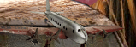

two hangers

## u:

## v:

## w:

whisk broom 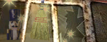

wine jug 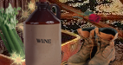

work boots 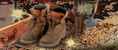

wreath

## x:

## y:

z:

# 2nd floor

# guest bath room：

a:

accordion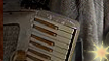

aninal tusk

ashtray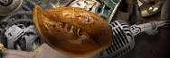

asparagus 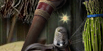

## b:

ball of yarn 

barbell 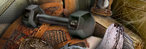

beetle 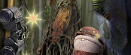

bust

boot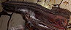

bell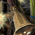

bank 存钱罐

## c:

camera 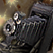

cat 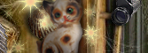

catfish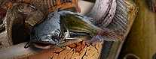

caterpillar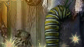

chisel

corkscrew 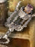

comb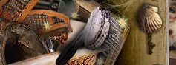

c-clamp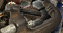 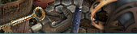

cloth sack 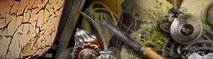

clock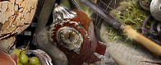

compass 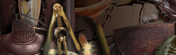

creamer 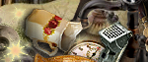

cymbals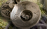

## d:

dragon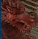

drum 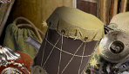

dinosaur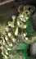

e:

eggplant 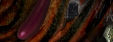

## f:

fan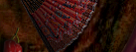

feather 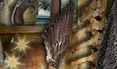

film reel 

fossil

## g:

garlic press 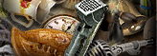

grapes 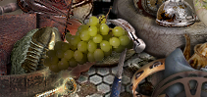

## h:

hammer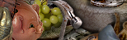

handcuffs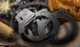 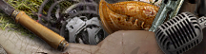

handbag 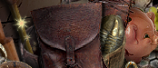

i:

j:

k:

## l:

lantern 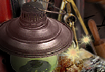

letterl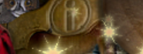

## m:

mask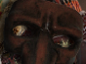

measuring tape 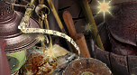

muffin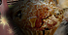

mistletoe 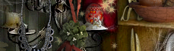

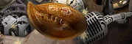

mouse 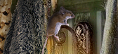

n:

## o:

oil can 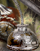

owl 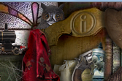

## p:

pistol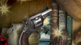

praying mantis 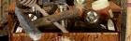

plunger 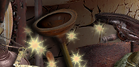

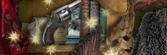

## q:

## r:

rabbit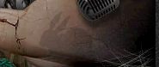

Russian doll

rolling pin擀面杖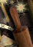

## s:

safari hat 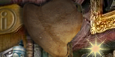

scale

scissors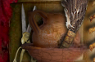

seashell 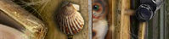

snowshoes 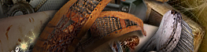

## t:

teapot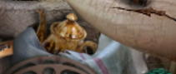

train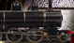

tambourine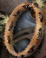 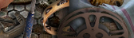

## u:

Ukrainian egg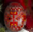

umbrella 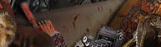

## v:

vertebrae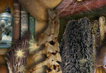s

violin 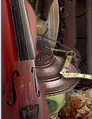

w:

x:

y:

z:

# Taxidermy room：

## a:

## b:

bananas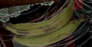

bacon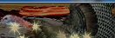

bass

bellows

brush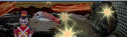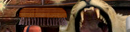

bug sprayer

bullet 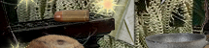

## c:

clothespin

coconut 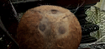

cog 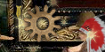

compass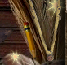

crutch 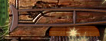

crogust mallet 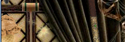

cup and saucer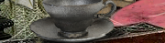

## d:

## e:

evil face 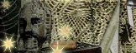

## f:

fan 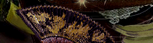

feather 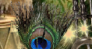

flashlight 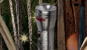

fudge stick 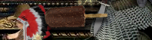

## g:

## h:

hammer

heart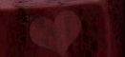

## i:

ice cream cone

## j:

## k:

## l:

lightning bolt

## m:

maraca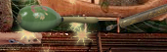

## n:

neefle 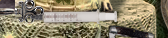

## o:

obelisk

## p:

pair of bolts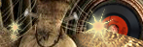

paper air plane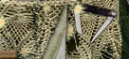

peas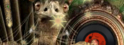

pencil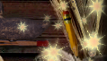

## q:

## r:

record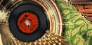

rose 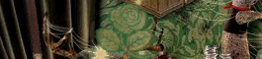

## s:

seashell

shamrock

stethoscope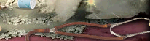

## t:

tassel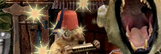

thre

thread spool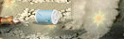

## u:

## v:

violin

## w:

wallet 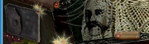

## x:

## y:

z:

# living room：

a:

artichoke

## b:

badge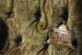

banana 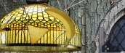

bell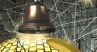

boomerang飞镖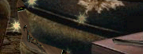

bottle 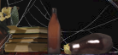

bowl of fruit 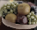

boxing glove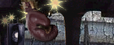

bust

## c:

corn chip

cactus 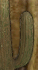

collar 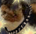

cuffs

## d:

devil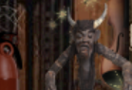

drawing square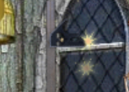

duck 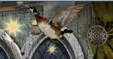

dumbbell 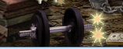

e:

eggplant 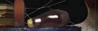

element 

Eiffel tower

## f:

fire extinguisher 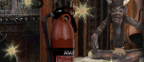

fork 

fly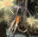 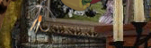

flashlight 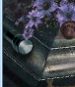

## g:

gavel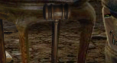

## h:

hand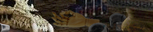

honey dripper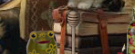

horseshoe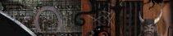

## i:

## j:

## k:

knocker 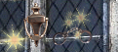

## l:

lizard

## m:

## n:

## o:

onion洋葱 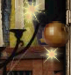

oil can 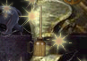

## p:

parking meter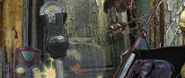

penguin 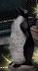

peppers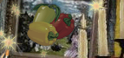

pear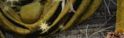

phones 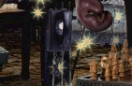

pipe

pineapple 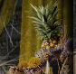

q:

r:

## s:

seahorse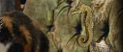

shackles

shovel 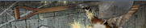

snowflake

spear

sun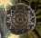

t:

thimble 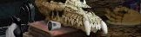

tiki

u:

umbrella

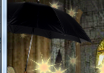

v:

w:walking stick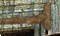 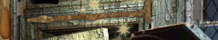

x:

y:

z:

# music room

## a:

antenna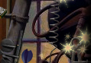

anvil 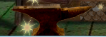

artichoke 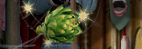

## b:

balance 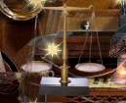

bicycle pump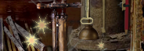

## c:

calipers

clothespin

comb 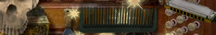

coin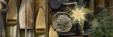

crown 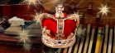

crayon 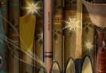

## d:

dart 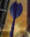

dice

## e:

## f:

false teech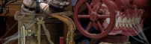

flower 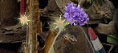

folding ruler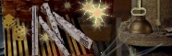

football 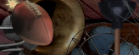

fountain pen

## g:

grapes 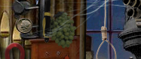

## h:

harmonica

hourglass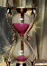

## i:

## j:

## k:

## l:

loud tie

## m:

magnet

maple leaf 

mask 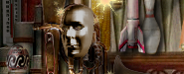

mouse trap 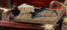

megaphone 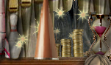

meter 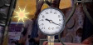

microphone 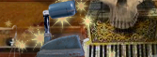

mothball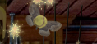

## n:

nest 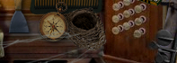

noose

## o:

oilcan 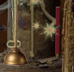

owl 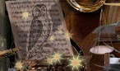

## p:

paint scraper 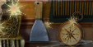

plunger 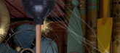

## q:

## r:

rat

rocket ship 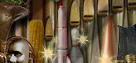

## s:

safety pin 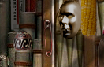

sandwich

saxophone 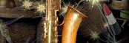

sharpener 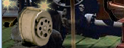

shoe tree

spike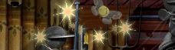

## t:

telescope 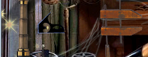

thermometer

three eggs 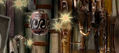 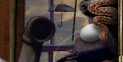 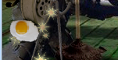s

three compasses 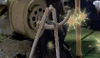 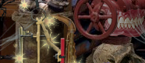 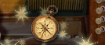

tongs

tuba

two garden tools

two snakes 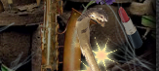 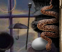

## u:

umbrella 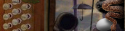

## v:

vertabrae 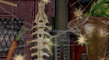

## w:

wooden clamp 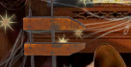

## x:

## y:

## z:

# backyard：

## a:

acorn 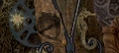

alligator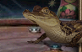

artichoke

arrowhead 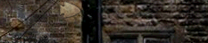

## b:

balloons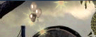

banana

buddha 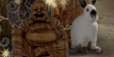

bullet 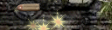

bunny

boots 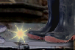

bow 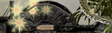

box knife 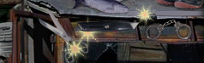

## c:

canoe 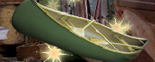

carrot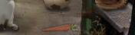

clamp

clothespin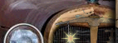

corkscrew 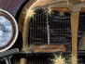

corndog 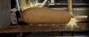

cuffs 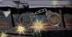

can opener 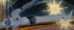

## d:

dart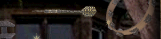

dolphin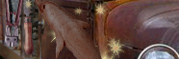

## e:

egg timer 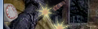

## f:

fish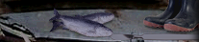

file 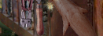

film reel 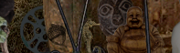

flute

## g:

giraffe

grapes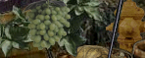

## h:

hacksaw 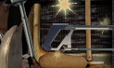

hanger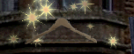

hat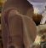

hydrant 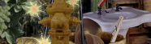

## i:

ice cream 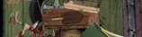

## j:

## k:

## l:

lantern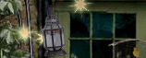

## m:

## n:

## o:

## p:

pen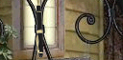

pick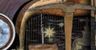

## q:

## r:

razor 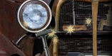

## s:

seahorse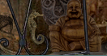

scalpel 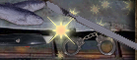

scissors剪刀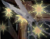

sink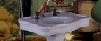

snake 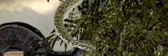

spider 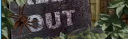

spigot 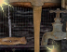

## t:

treble clef 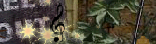

trash can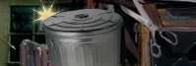

tricycle

turtle

two crowns 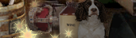 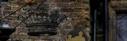

two masks 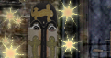

## u:

umbrella 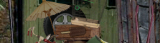

## v:

vise grips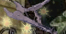

## w:

wooden doll

wire cutters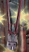

wrench 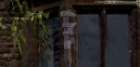

x:

y:

z:

比亚迪 秦500豪华 优惠多少？能否使用补贴？截止日期交定金还是全款？是否现车？

# 3rd floor

# study：

## a:

anchor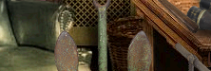

artichoke 

## b:

black glove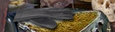

binoculars 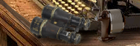

butterfly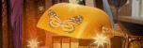

## c:

camera 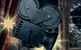

crown

## d:

doughnut

dragons 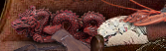

## e:

eraser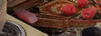

## f:

feather fan

flashlight

funnel 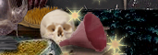

## g:

## h:

harmonica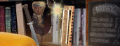

hairbrush 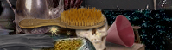

hand drill 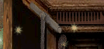

horn 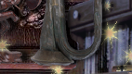

## i:

## j:

## k:

## l:

ladle 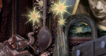

lizard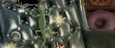

lobster 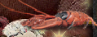

lungs 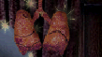

## m:

## n:

## o:

olive 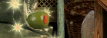

## p:

pipe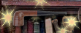

pocket watch

postage stamp 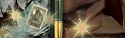

pretzel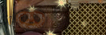

## q:

question 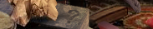

## r:

raspberries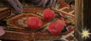

reflex mallet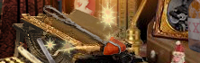

rope

## s:

scorpion

shackles 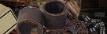

straight razor 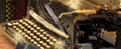

sharpener 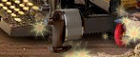

## t:

toy car 

trowel

tuning fork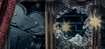

two daggers 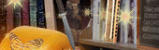 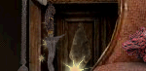

two umbrellas 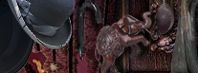 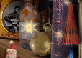

## u:

## v:

## w:

wagon wheel

wine bag 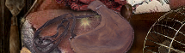

wine bottle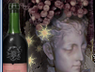

## x:

## y:

## z:

# Library：

## a:

army man 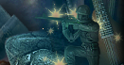

ashtray 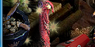

avocados 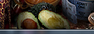

## b:

beer stein

brush 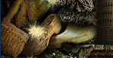

bongo drum 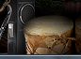

butterfly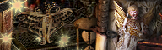

bug 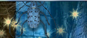

bull horns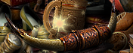

## c:

catcher’s mask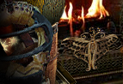

crab

croissant 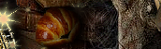

## d:

## e:

## f:

flashlight 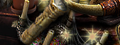

## g:

## h:

hammer 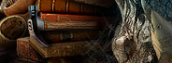

## i:

## j:

## k:

## l:

## m:

## n:

## o:

## p:

pistol

pizza 

## q:

## r:

robin 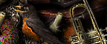

rope

rubber boots 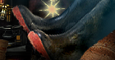

## s:

skull 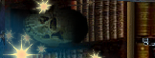

straw hat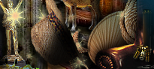

## t:

thimble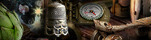

ticket roll 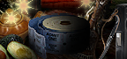

trumpet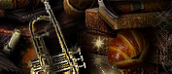

turtle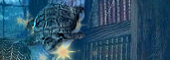

## u:

umbrella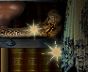

## v:

## w:

## x:

## y:

z:

# surveillance romm：

## a:

apple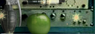

aspirin 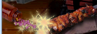

auger

## b:

bandage 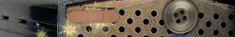

billiard ball

bike tire

bobber

bugle 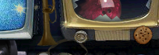

button 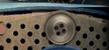

## c:

camera 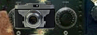

cherry

coeur in french 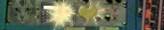

comb 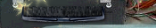



## d:

dial tone 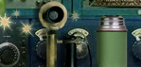

domino 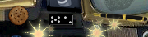

duct tape

## e:

envelope 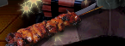

## f:

flashlight 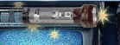

## g:

get stronger 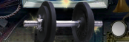

goggles

## h:

## i:

## j:

## k:

kitty

## l:

## m:

## n:

nuclear 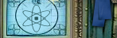

## o:

olive

## p:

peas 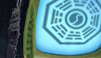

pig skin 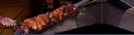

pipe wrench 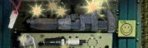s

## q:

## r:

rose 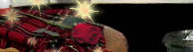

## s:

scorpion 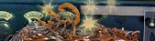

service bell 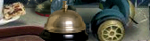

sewing button

smiley 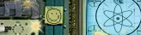

## t:

taco 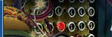

teapot

tnt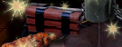

two bullhorns 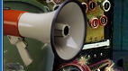 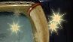

## u:

## v:

## w:

walkie-talkie 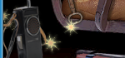

watermelon

## x:

## y:

yummy kabob 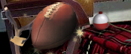

z:

# pantry：

## a:

## b:

bazooka 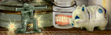

bolt 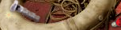

## c:

camera 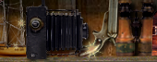

## d:

## e:

## f:

## g:

grapes 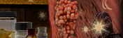

## h:

hand 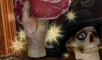

horseshoe 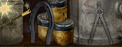

## i:

## j:

## k:

## l:

letter 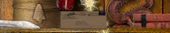

lion 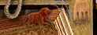

## m:

match 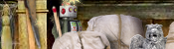

mouse 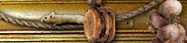

## n:

## o:

## p:

peeking eye 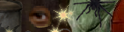

pencil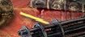

pick 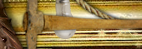

pocket watch 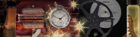

spatula

pulley 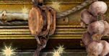

## q:

## r:

rope 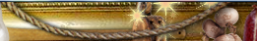

ruler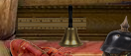

## s:

shell 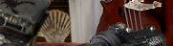

spatula 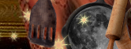

snake 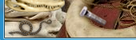

sushi 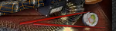

syringe 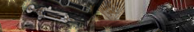

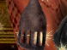

## t:

## u:

## v:

## w:

wishbone 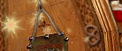

wrench 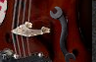

## x:

## y:

z:

# widow`s walk(tower)：

## a:

artichoke 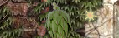

## b:

banana peel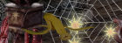

bat 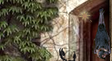

binoculars

bird house 

box knife 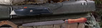

## c:

chalice

clamp 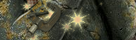

cinder block 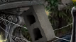

compass 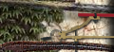

## d:

## e:

eggplant 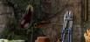

elephant 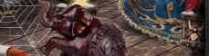

## f:

flower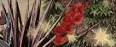

fly 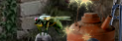

file 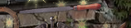

## g:

gas can 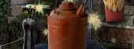

goose 

## h:

## i:

ice cream cone 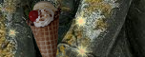

## j:

## k:

## l:

large fries

lobster 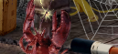

## m:

man’s face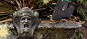

maraca 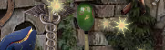

martini 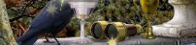

milk bottle 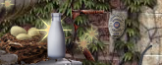

## n:

nest 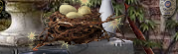

## o:

olive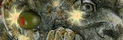

orange slice 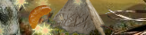

## p:

pencil 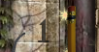

pepper 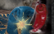

pie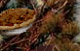

pigeon 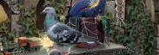

pipe 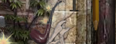

plunger 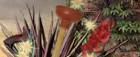

potato 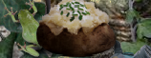

pyramid 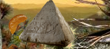

## q:

## r:

rubber ducky 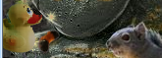

## s:

scorpion 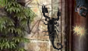

scythe 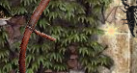

shovel 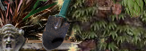

silly glasses

soldiers 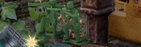

sombrero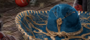

spider

suitcase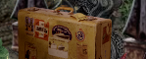

## t:

tea kettle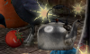

tomato 

tow frogs 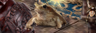 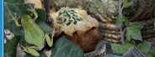

train 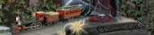

two planes 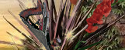 

## u:

## v:

vise grips

## w:

## x:

## y:

z:

# attic：

## a:

## b:

book stack 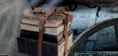

boomerang 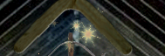

## c:

Christmas ornament 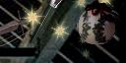

Crossbow

## d:

dagger 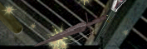

## e:

## f:

## g:

grapes 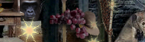

## h:

heart 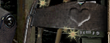

home sweet home 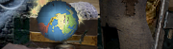

## i:

## j:

## k:

## l:

## m:

medal 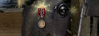

## n:

## o:

oars 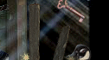

## p:

## q:

## r:

## s:

scissors

sliced bread

steering wheel 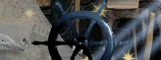

## t:

tnt 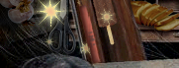

## u:

## v:

## w:

## x:

## y:

z:

# storage room：

## a:

air freshener 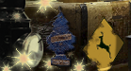

## b:

bee 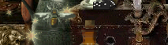

## c:

## d:

disguise 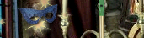

## e:

eightball 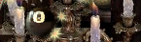

## f:

## g:

## h:

heart 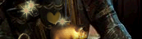

## i:

## j:

## k:

## l:

## m:

mop 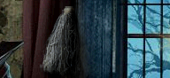

## n:

## o:

## p:

## q:

## r:

## s:

## t:

twine ball 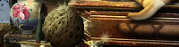

## u:

## v:

Viking helmet 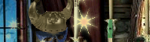

## w:

## x:

## y:

z:

# TREEHOUSE：

## a:

apple half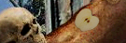

## b:

banana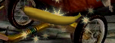

bear 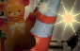

bottle opener 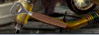

bowling ball 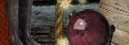

## c:

## d:

## e:

## f:

feline 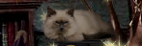

fish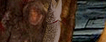

fishing rod 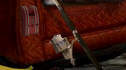

football helmet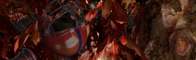

## g:

gavel 

geisha 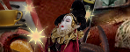

## h:

horseshoe 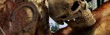

## i:

## j:

## k:

## l:

level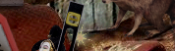

## m:

mitt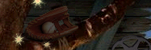

## n:

## o:

## p:

pick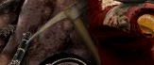

plane 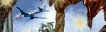

## q:

## r:

razor

rooster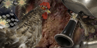

reel 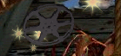

## s:

saw 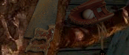

seagirse 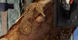

shell 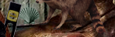

stapler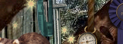

## t:

tape 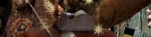

## u:

## v:

## w:

## x:

## y:

z:

# shed：

## a:

anvil 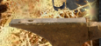

## b:

burger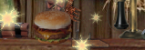

## c:

cat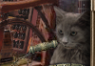

cheese 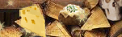

## d:

## e:

earphones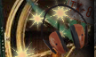

## f:

fan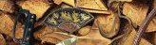

first place 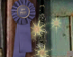

footwear 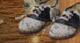

funnel

## g:

## h:

horse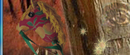

## i:

## j:

## k:

knife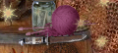

## l:

## m:

monkey 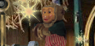

## n:

nuts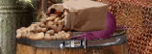

## o:

oil can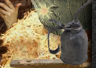

## p:

pen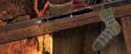

phone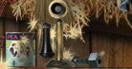

## q:

## r:

record player

red bottle

## s:

saw

soup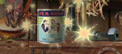

spice jars

## t:

taco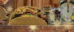

## u:

umbrella 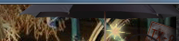

## v:

## w:

whisk broom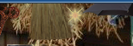

wrench 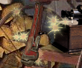

## x:

## y:

yarn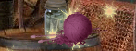

yellow bottle 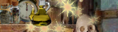

z:

# 模板：

## a:

## b:

## c:

## d:

## e:

## f:

## g:

## h:

## i:

## j:

## k:

## l:

## m:

## n:

## o:

## p:

## q:

## r:

## s:

## t:

## u:

## v:

## w:

## x:

## y:

z: